**Lab 8 DB**

**K226007**

**Yousha Mehdi**

**BCS-5L**

**Task1:**

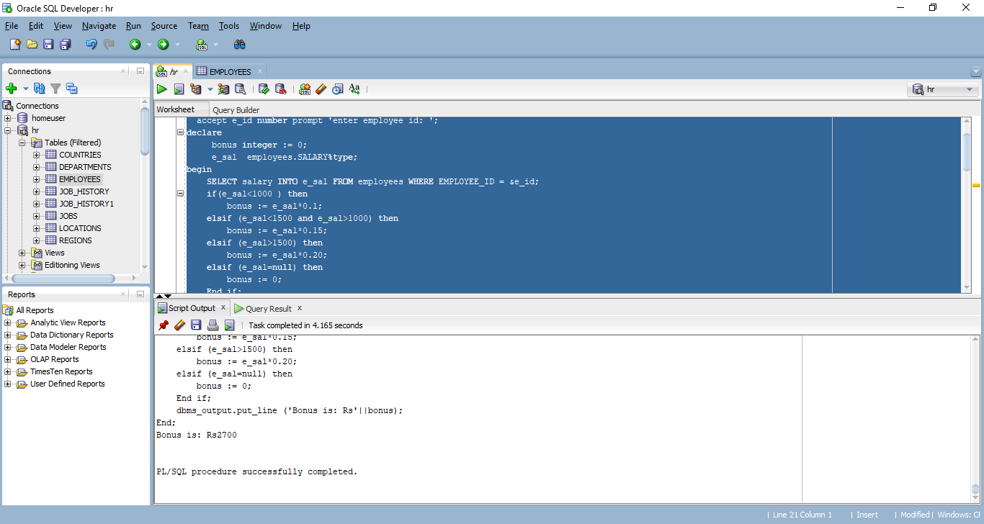

-- Task1 a

set serveroutput on

accept e_id number prompt 'enter employee id: ';

declare

bonus integer := 0;

e_sal employees.SALARY%type;

begin

SELECT salary INTO e_sal FROM employees WHERE EMPLOYEE_ID = &e_id;

if(e_sal<1000 ) then

bonus := e_sal*0.1;

elsif (e_sal<1500 and e_sal>1000) then

bonus := e_sal*0.15;

elsif (e_sal>1500) then

bonus := e_sal*0.20;

elsif (e_sal=null) then

bonus := 0;

End if;

dbms_output.put_line ('Bonus is: Rs'||bonus);

End;

**Task2:**

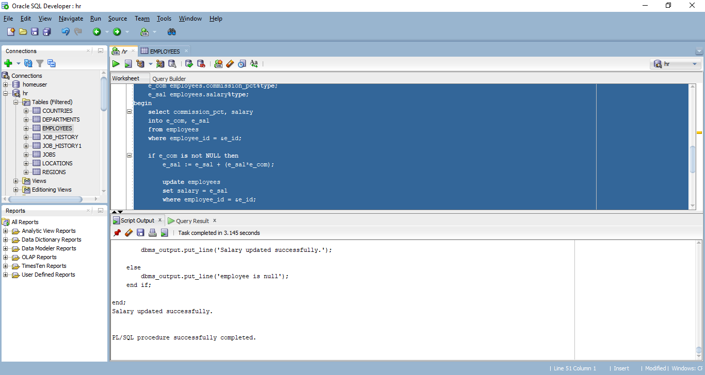

sk2

set serveroutput on

accept e_id number prompt 'enter employee id: ';

declare

e_com employees.commission_pct%type;

e_sal employees.salary%type;

begin

select commission_pct, salary

into e_com, e_sal

from employees

where employee_id = &e_id;

if e_com is not NULL then

e_sal := e_sal + (e_sal*e_com);

update employees

set salary = e_sal

where employee_id = &e_id;

dbms_output.put_line('Salary updated successfully.');

else

dbms_output.put_line('employee is null');

end if;

end;

**Task3:**

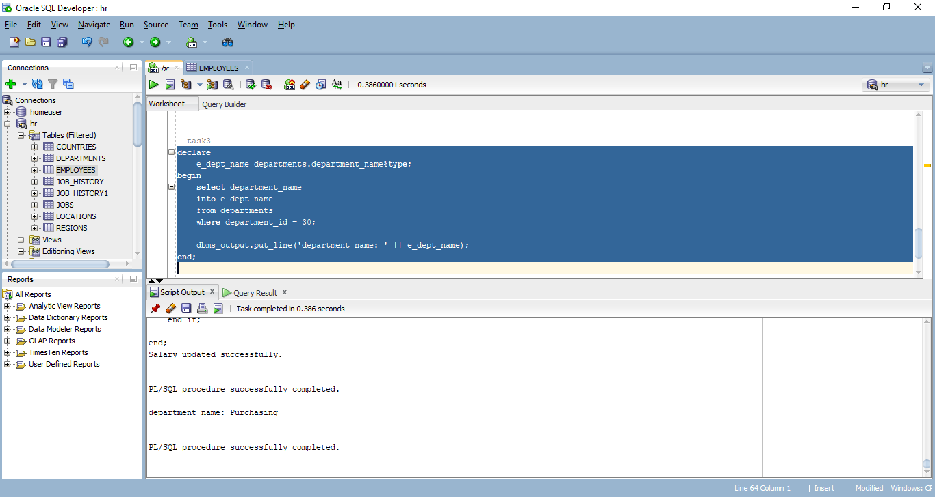

declare

e_dept_name departments.department_name%type;

begin

select department_name

into e_dept_name

from departments

where department_id = 30;

dbms_output.put_line('department name: ' || e_dept_name);

end;

**Task4:**

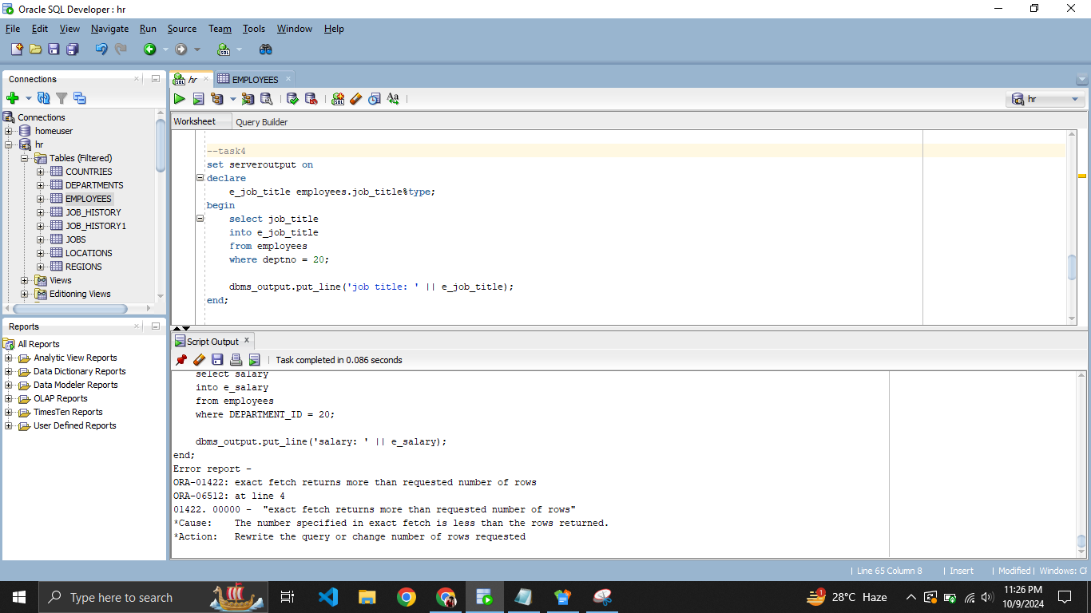

--task4

set serveroutput on

declare

e_job_title employees.job_title%type;

begin

select job_title

into e_job_title

from employees

where deptno = 20;

dbms_output.put_line('job title: ' || e_job_title);

end;

**Task5:**

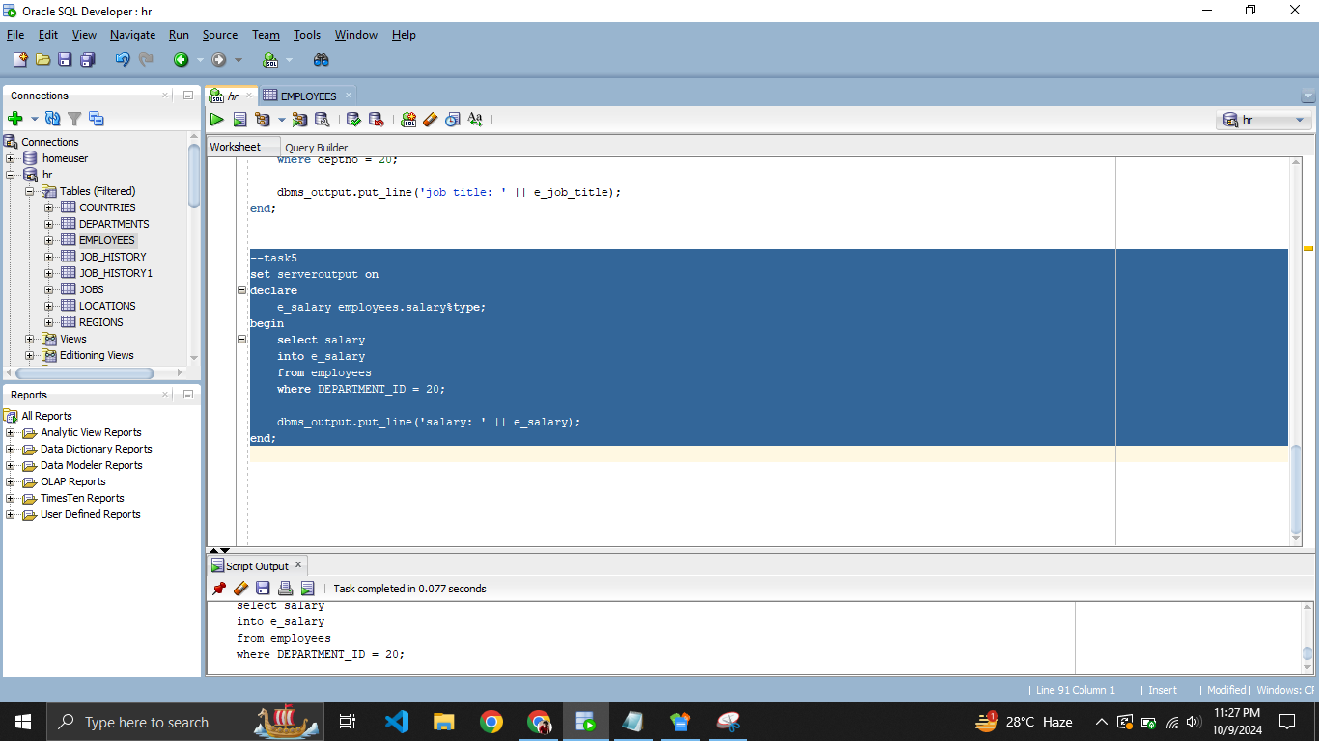

--task5

set serveroutput on

declare

e_salary employees.salary%type;

begin

select salary

into e_salary

from employees

where DEPARTMENT_ID = 20;

dbms_output.put_line('salary: ' || e_salary);

end;